

Table of Contents






4
7
10
12
15
17

© 2013, The Franklin Institute, Philadelphia, PA. Published under a Creative Commons Attribution-Noncommercial 3.0 Unported license: http://creativecommons.org/licenses/by-nc/3.0/deed.en_US

Introduction

What are these demonstrations about?

These activities explore the technology of personal electronic devices. With real electronics and interactive models of “software” and “hardware” functions, visitors will discover how pocket-sized computers input, store, display, and communicate information to connect us to the world. These activities build understanding of everyday technology and provide insight into emerging materials science and computational research.

Who created these demonstrations?

These demonstrations were created by The Franklin Institute and the Penn State University Center for Nanoscale Science. AT&T generously donated smartphones to be used in support of the demonstrations. Funding was provided by the National Science Foundation under Grant DMR-08-20404, via the interdisciplinary Materials Research Science and Engineering Center (MRSEC) program.

What other preparations are necessary to start the demonstrations?

Computer Speak and Computer Logic require some preparation before first-time use; you will have to cut out graphics and assemble the magnetic pieces. For ongoing use, make sure that the smartphone is charged and operational, and that you have working batteries for Screen Orientation, Touch Screens, Color Displays, and Signal Transmission.

What can I do if I need more information?

Contact Jayatri Das, Chief Bioscientist at The Franklin Institute, at jdas@fi.edu or look at the website for this project (http://www.mrsec.psu.edu/education/museum_shows/pocket_tech/). All graphics and digital files will be posted to the project website as well.

Should all the demonstrations be done at the same time?

No, that would take too much time. You should do up to three or four at a time, depending on your audience, context, space, and interest. You may find that some of the demonstrations work well together, such as Touch Screens and Color Displays.

Do I have to do everything exactly as the script says?

No, each museum’s audience is different, and each presenter has his or her own style. Feel free to adapt and edit the script for your audience. Please make sure your science is accurate and the procedures are safe.

What are the fact sheets for?

The Center for Nanoscale Science created the fact sheets to extend the breadth and depth of the script explanations. This additional content can be used for staff training, enhancement of the basic script, or as a resource for deeper discussions with interested visitors.

Key Terms

Accelerometer: an electronic component that detects tilt and motion by sensing acceleration with respect to the force of gravity

Antenna: an electronic component used to broadcast and receive electromagnetic waves

American Standard Code for Information Interchange (ASCII): a standard set of binary numeric codes widely used in computer systems to represent English letters, numbers, and punctuation symbols

Binary code: the fundamental coding system used by computers in which the digits 0 and 1 represent letters, numbers, characters, and many other central processing instructions

Bit: the basic unit of information in computing, most commonly represented as 0 and 1

Byte: a sequence of 8 bits; the smallest unit of information processed by a computer

Capacitance: the amount of electrical charge stored by an object, often via two parallel conductive surfaces separated by a nonconductive materials

Liquid crystal display (LCD): a video display that uses the light-filtering properties of special materials that flow like liquids but maintain an ordered molecular structure (like solids)

Logic gate: the basic building block of a computer circuit; converts inputs to outputs based on defined rules for a single operation

Logic tree: a diagram representing all inputs, outputs, and logic gates involved in a computational function

Microphone: an electronic component that converts sound waves into electrical signals

Pixel: a single point in a graphic image

Receiver: an electronic component that converts the signals sent to it by the antenna into a form that can be interpreted and used by the device

Subpixel: the part of a pixel that shows the amount of red, green, or blue in that point of the image

Speaker: an electronic component that converts an electrical signal into sound waves

Transistor: an electronic component that can switch a current on and off; in a computer, switching between the two states corresponds to switching between 0 and 1

Transmitter: an electronic component that converts electrical signals from a device into the appropriate electromagnetic frequencies needed for the antenna to broadcast

Truth table: a diagram that defines all possible inputs and outputs of a logic function

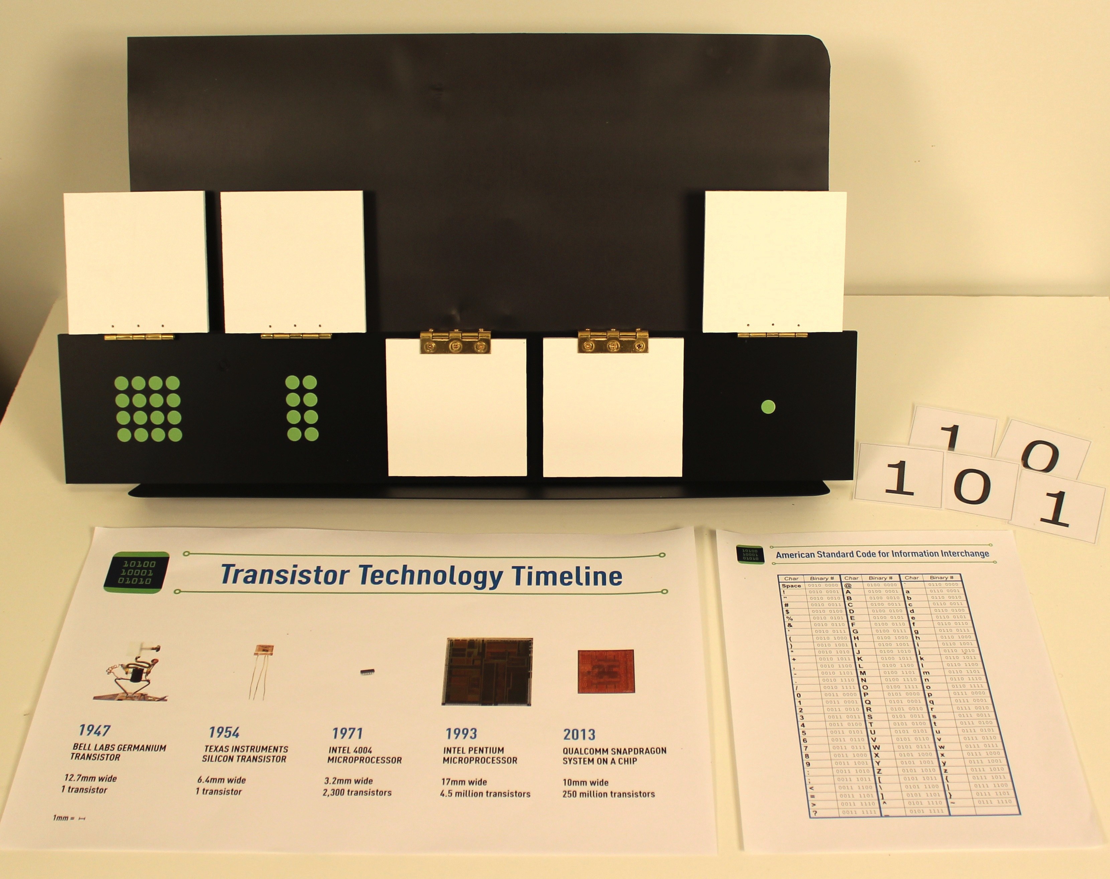
Goal:

Visitors will learn how 0s and 1s can represent information.

Materials:

- Display stand (optional)
- Binary flip board
- 0/1 tiles (5)
- Graphic of ASCII table (optional)
- Graphic of transistor timeline (optional)

Procedure:

Set-up:

- Set out the binary flip board on the display stand. Flip all five panels up so that all the dots are visible. Have the 0/1 tiles and graphics on hand and out of visitors’ sight.

Doing the demonstration:

- Ask visitors if they have ever used a code to write a message. Explain that they will be putting their birthdate into a code.

- Ask one volunteer his or her birthdate (the day of the month, not the year). Show the visitor the flip panels. Have the visitor flip the panels down so that the total number of dots showing is equal to their birthdate. Any number between 0 and 31 can be made.

- Tell visitors that they will now translate the number into a code by using a 0 for every panel that is flipped down (dots not visible) and a 1 for every panel that is flipped up (dots visible). Have a volunteer place a 0/1 tile, with the appropriate side up, on the table below each panel.

- Explain that the code we used is called “binary code.” Binary code is how computers “speak” because they communicate and store all information as 0s and 1s. For example, we usually write the number twenty-one as “21,” but a computer would code twenty-one in binary as 10101. If visitors are confused, it may help to point out that the same number can be written with either words or numbers (“twenty-one” vs. “21”) and suggest that computers just think of them in a third way.

Optional steps for deeper exploration:

- Having coded the number, now ask visitors how, if they used a similar code to write a message for a friend, would their friend know how to read it? Their friend would also need to know the code. Show visitors the much more complex ASCII table to demonstrate what computer scientists actually use. Having one code shared between every computer allows most computers, and their programs, to talk to each other and work together.

- Ask visitors to name some things that they do with smartphones, computers, or other personal electronics. Explain that all of those functions rely on this code of 0s and 1s because of many small components called transistors inside a computer chip that switch between two states–on and off–to make complex calculations. The two states of a transistor are what make binary code the language computers use to “speak.”

- Show visitors the graphic of how transistors have changed over time and ask what they notice about the size and number of transistors. New materials and structural designs have led to smaller transistors, allowing the computing power of handheld electronics to increase dramatically. Today researchers are trying to find new ways of processing binary coded information to make computers even smaller, faster, and more powerful.

- Visitors who are interested in experimenting further can try counting on the flip board, starting with zero. Ask if they see a pattern in the way they flip the panels while counting. Is there more than one way to make a number? What is the highest number that can be shown with the flip cards?

Clean-up:

- Return the flip board, 0/1 tiles, and graphics to storage.

Explanation:

Each position on the flip board in this activity represents one bit (digit) of the binary code. A single bit of data can be one of only two values, 0 or 1. Like our normal decimal number system, the binary system uses place value, meaning that the digits in different columns represent increasing orders of magnitude. In binary code, the columns are (from right to left) represent the powers of two: 2⁰=1, 2¹=2, 2²=4, 2³=8, 2⁴=16, etc. The number of dots at each position corresponds with its place value. The dots can only be seen when the panel is flipped to the up, or “1,” position. This is how the number of dots is translated into the number shown in binary code with the tiles along the bottom of the board.

Because binary numbers are written with only 0 and 1, computers can handle them as a series of on and off switches. However, letters and symbols do not translate as easily to 0s and 1s. If you had a series of switches that could only be on or off, how could you write a message with them? You would need to define what certain combinations of on and off switches stand for; in other words, you would need a code. Anyone who wanted to read your message would also need to know the code. There is a standard code that computers use called the ASCII (American Standard Code for Information Interchange). Each character in this code is written with eight bits because computers are designed to combine eight bits together into a unit called a byte. A byte of data can have 2⁸ = 256 different values.
Transistors are the fundamental component of all electronic computing devices. While all types of transistors function similarly, the materials that are used to make them, their structural designs, and the details of how they work are very complex. In this demonstration, the transistor is mentioned only to help explain why computers use binary code, as well as why computing power has seen such tremendous growth. The first solid state transistor from Bell Labs in 1947 was a truly revolutionary invention. The first silicon transistor made by Texas Instruments improved performance and made mass commercial production possible. In the late 1950s, integrated circuits allowed microchips to be made much smaller than circuits made from discrete transistors, and the Intel 4004 was the first commercially available microprocessor that incorporated all central processing functions on a single chip. The Intel Pentium microprocessor represents the huge improvements in speed and structure made in the 1990s. Today, smartphones are made possible by “systems on a chip” like the Qualcomm Snapdragon, where all computing functions including the operating system, graphics, communications, and hardware are all run off of a single chip.

WHAT COULD GO WRONG?

Because codes are often used to maintain security, some visitors may become confused about why computers use codes. Binary and the ASCII are not secret codes. Computers use codes because they are physically limited to storing 0s and 1s. Avoid the use of words like “secret” when talking about codes.

Another possible source of confusion is that the ASCII table gives letters and symbols an equivalent eight-bit binary number. However, this activity only uses five bits (allowing 32 possible values) for the sake of simplicity.

The ASCII table and transistor information may be too complex for younger audiences. These are not necessary to use to communicate the basic message of this activity.

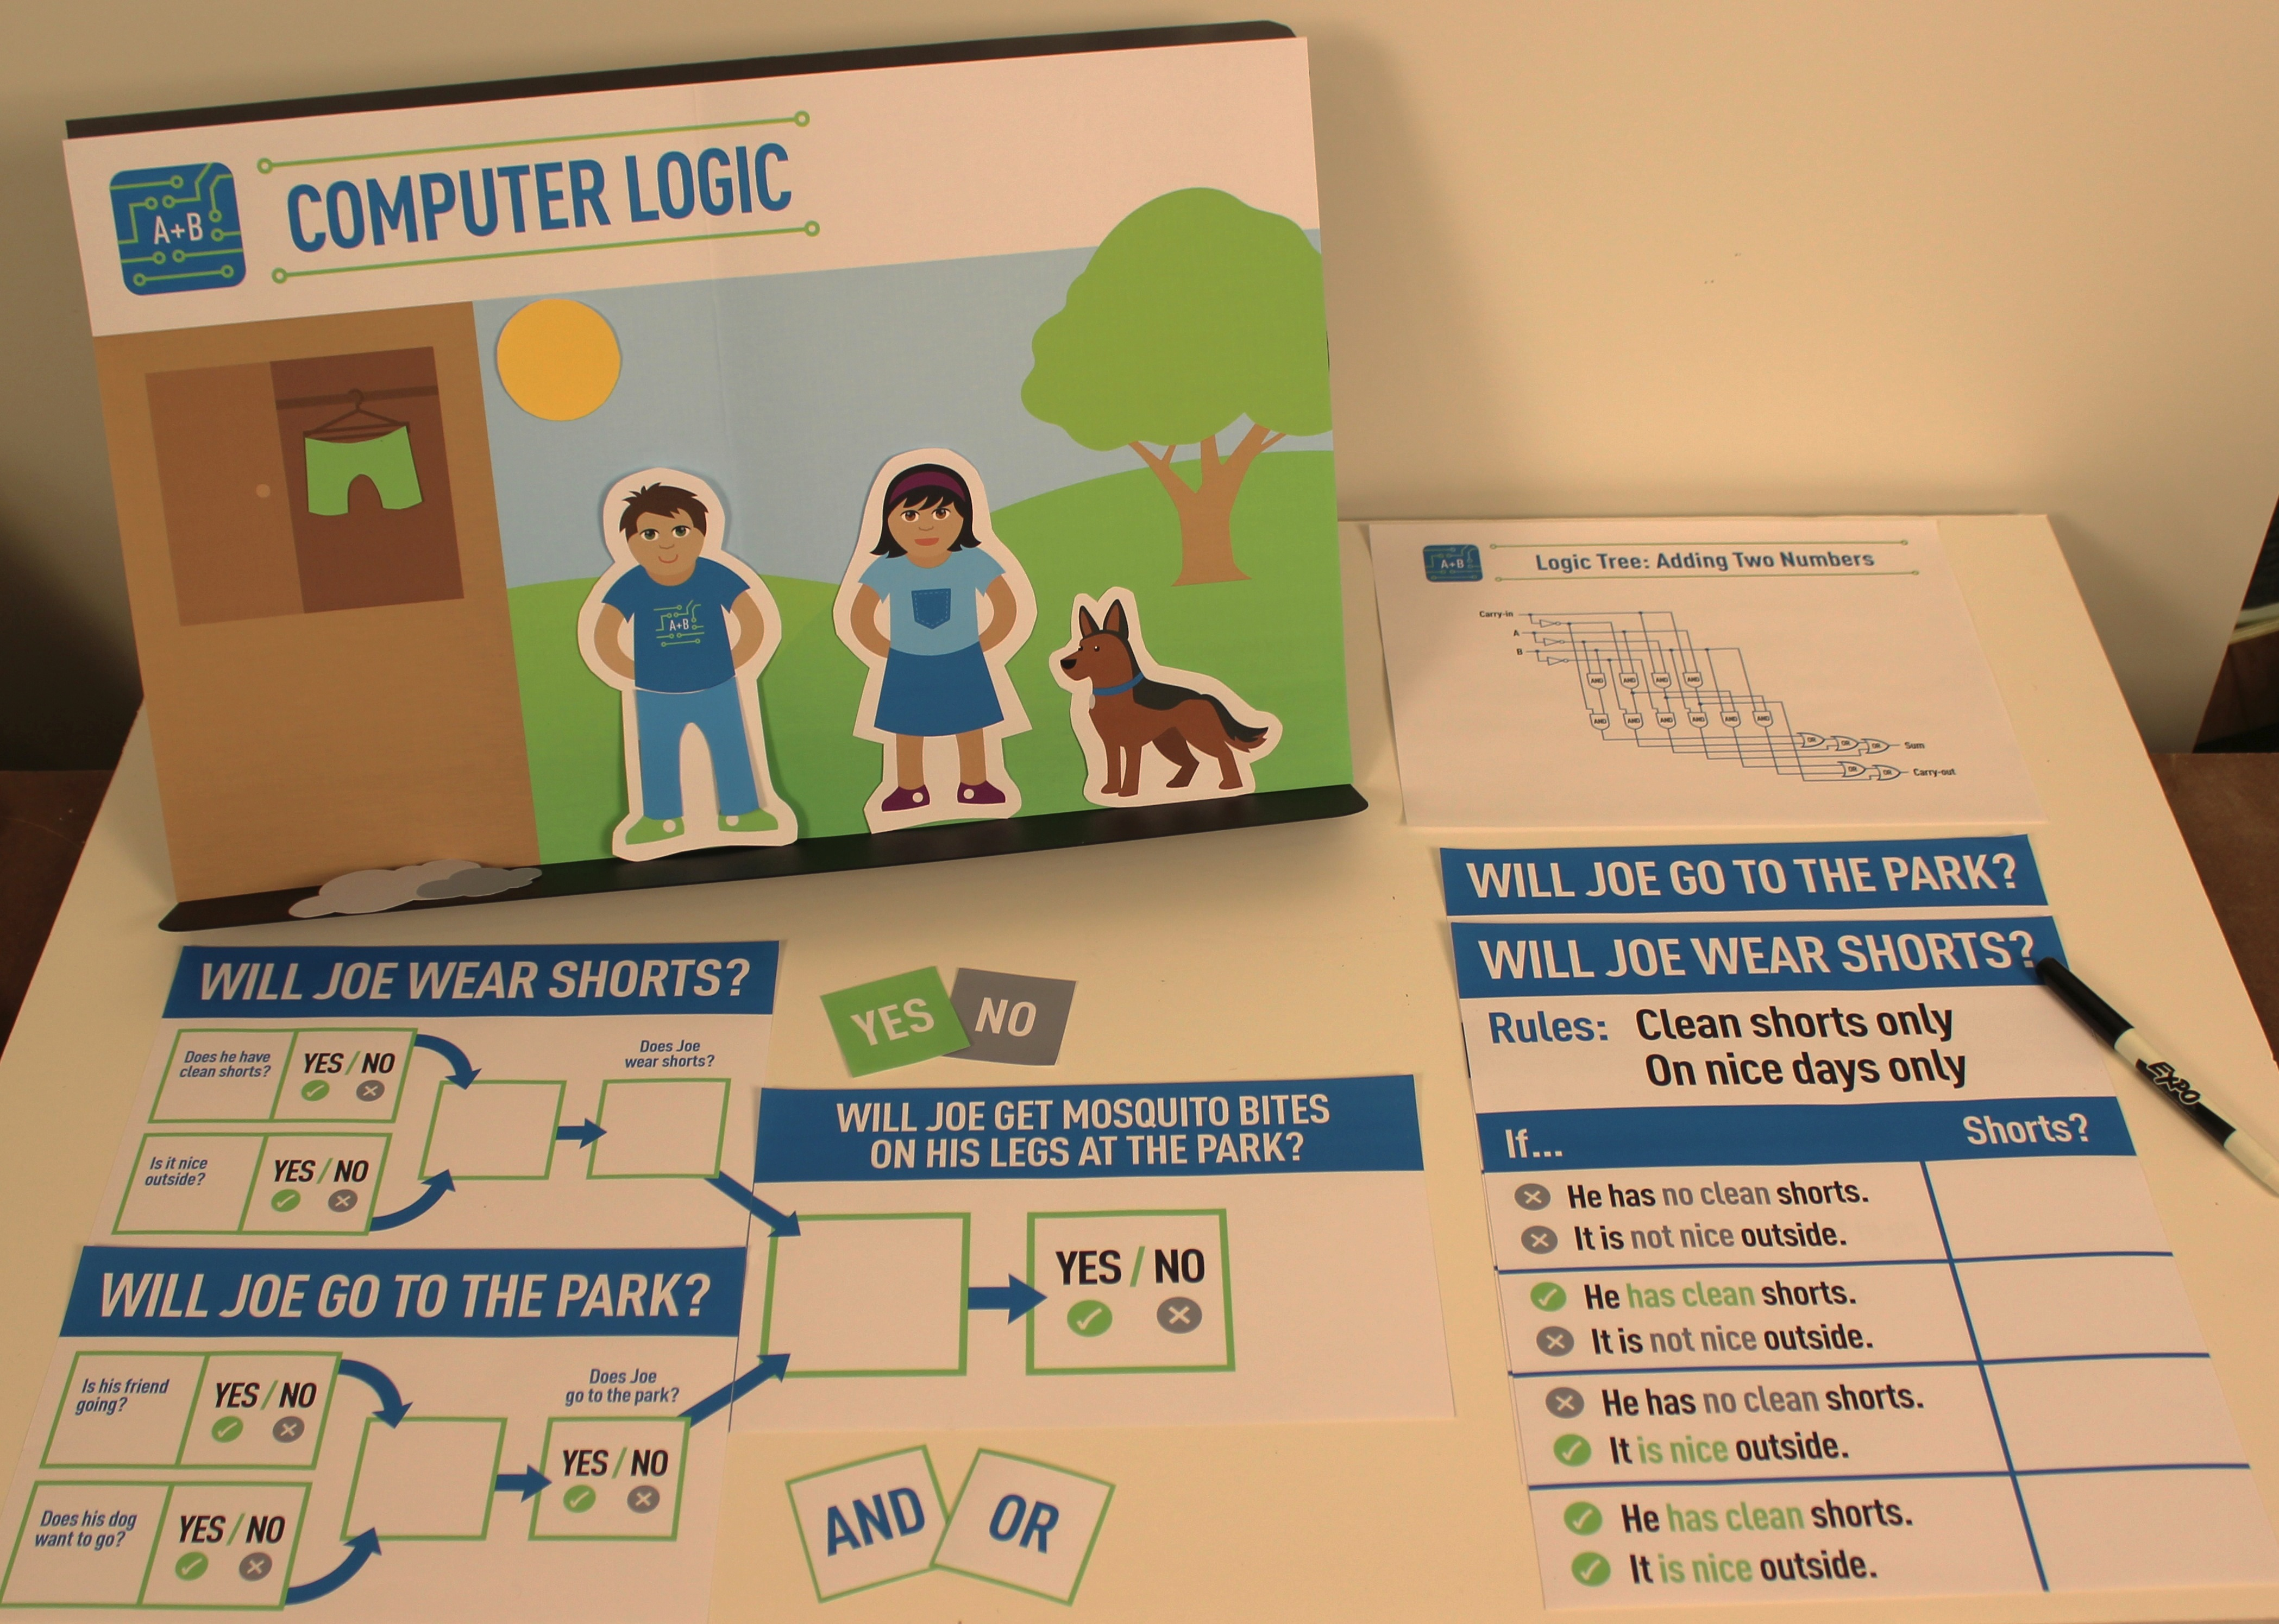
Goal:

Visitors will learn how computers are programmed to make decisions.

Materials:

- Display stand
- Graphic of background scene
- Magnetic characters and props (Pat, friend, dog, shorts, pants, cloud, sun)
- Truth table graphics (Will Pat wear shorts? and Will Pat go to the park?)
- Logic tree templates (Will Pat wear shorts?, Will Pat go to the park?, Will Pat’s legs get mosquito bites at the park?)
- Logic gate tiles (AND and OR)
- YES/NO value tiles
- Graphic of logic tree (optional)

Procedure:

Set-up:

- Put the background scene graphic on the display stand.

- Choose two characters to be Pat and a friend. Decide whether or not to place the magnetic shorts prop inside the wardrobe (you can also have visitors help with setting up the story). Have the other materials at hand.

Doing the demonstration:

- Ask visitors how they make a decision like what to wear in the morning. Computers also need to think about information and make decisions, but they must be programmed with rules about how to make a decision. Tell visitors that we will be programming a simple computer to help our new friend, Pat, decide what to wear.

- Tell visitors that the first step in programming our computer is to decide when Pat will and will not wear shorts. Show visitors the Will Pat wear shorts? truth table. Pat has some rules that determine when to wear shorts: only if shorts are clean, and only on nice days. Have visitors fill out the truth table using the YES/NO tiles. They should only answer YES under the condition that Pat has clean shorts and the weather is nice.

- Tell visitors that the next step is to make a logic tree to instruct our computer how to make a decision. Show visitors the Will Pat wear shorts? logic tree template. Point out that our two input questions are written on the left side and our main question is written on the right. The gap in the middle of the logic tree is where we put a logic gate. What kind of logic gate we use will determine how the computer will answer our question. Remind visitors how they decided when Pat will wear shorts–only if both the shorts are clean and the weather is nice. Computer programmers use an AND gate for that logic function. Place an AND tile on the logic gate space.

- Now visitors can make the decision for Pat. Ask visitors to check the wardrobe for clean shorts and attach either the sun or the cloud to the sky of the park scene (depending on the weather outside that day). Have them use value tiles to fill in the inputs and outputs of the logic tree and put the correct clothes on Pat.

Optional steps for deeper exploration:

- Set the Shorts template aside and bring out the Will Pat go to the park? truth table. Repeat the exercise with this question. Pat also has rules about going to the park: Pat will go with a friend, or with his dog, but he won’t go there alone. Have visitors fill out the truth table. They should answer YES under the three conditions that Pat’s friend is going, the dog wants to go for a walk, or if both the friend and dog want to go.

- Show visitors the Will Pat go to the park? logic tree template. Remind visitors how they decided when Pat will go to the park–when either or both the friend and dog want to go. A different logic gate is needed for this situation. See if they can guess that this is an OR gate. Place an OR tile on the logic gate space. Give the friend and dog characters to visitors and ask them if they’re going to the park. Have visitors fill in the inputs and output based on that information.

- Tell visitors that computers can also combine decisions to answer more complicated questions like “Will Pat’s legs get mosquito bites at the park?” Bring out all three logic tree templates. Show visitors that the final part of the tree combines the previous two. Have visitors choose whether to place an AND or an OR on the final logic gate. If necessary, point out that, to get mosquito bites on his legs at the park, Pat must both wear shorts and go to the park. The correct answer is AND. Finally, have visitors fill in the final output space with a value tile–by programming rules of lower level decisions, the computer can answer a more complex question.

- Ask visitors if there are other factors that could influence whether they wear shorts or go to the park. Explain that one of the limitations of computers is that they must be programmed by a human. A computer cannot account for any factors that have been left out of its programming.

- While we don’t usually use computers to decide simple things like what to wear, computers still need to be able to make calculations, evaluate information and draw conclusions. Show visitors the graphic of a real logic tree (depicting how a computer adds two binary numbers together, a relatively simple operation) to demonstrate that they can get very complex very quickly. A more detailed explanation of the logic tree can be found in the Computer Speak fact sheet.

Clean-up:

- Gather the loose tiles, characters, and props together. Place all materials in a folder and return it to storage.

Explanation:

Logic gates take one or more inputs, apply a logical operation, and produce a single output. Different kinds of logic gates perform different operations. A logical function can be expressed in a truth table, such as the examples below. A truth table shows all possible inputs and outputs of the operation.

The two functions illustrated below are AND and OR. There are other kinds of logic gates, but AND and OR are two basic examples. A logic gate that performs the AND function gives an output of true if both inputs are true, while one that performs the OR function gives an output of true if at least one input is true. An AND gate is like a light bulb attached to two switches in series. The circuit is completed and light comes on only if both switches are on. An OR gate resembles a parallel circuit. The circuit will be completed if one or both switches are on. Like a light switch, a computer thinks in binary terms (on/off, yes/no, up/down, etc.). It is helpful to think of these binary values as being true (1) or false (0).

Inputs |  | Operations
A | B | A AND B | A OR B
0 | 0 | 0 | 0 | Outputs
0 | 1 | 0 | 1 | Outputs
1 | 0 | 0 | 1 | Outputs
1 | 1 | 1 | 1 | Outputs

In most electronics, logic gates are made up of transistors acting as switches. Individual logic gates, each performing a simple operation, can be combined to make complex logical systems represented graphically in logic trees. This forms the basis of computing. Computers must be able to make logical decisions based on input data. For example, to win a computer game, you may have to meet multiple criteria, such as reaching a certain level or getting a minimum score. One or more logic gates “consider” each requirement (input) and decide whether you have won or not (output).

What could go Wrong?

This activity is complex, but can be easily adjusted for audiences at different levels by stopping at different points in the script. You can do just the first truth table and circuit to demonstrate how computers use rules to make decisions. For the next level, adding the second truth table and circuit demonstrates that there are different types of logic gates. The most advanced level adds the third circuit component to show that complex decisions can emerge from basic logic, and includes the example of the real logic tree for a simple computational function.

Visitors must come up with the correct truth tables in order to learn about both the AND and OR logic gates. It may be important to remind them to keep Pat’s rules in mind when answering the logic questions for him, not themselves.

General Maintenance:

All graphic files are available digitally and can be reprinted if necessary.
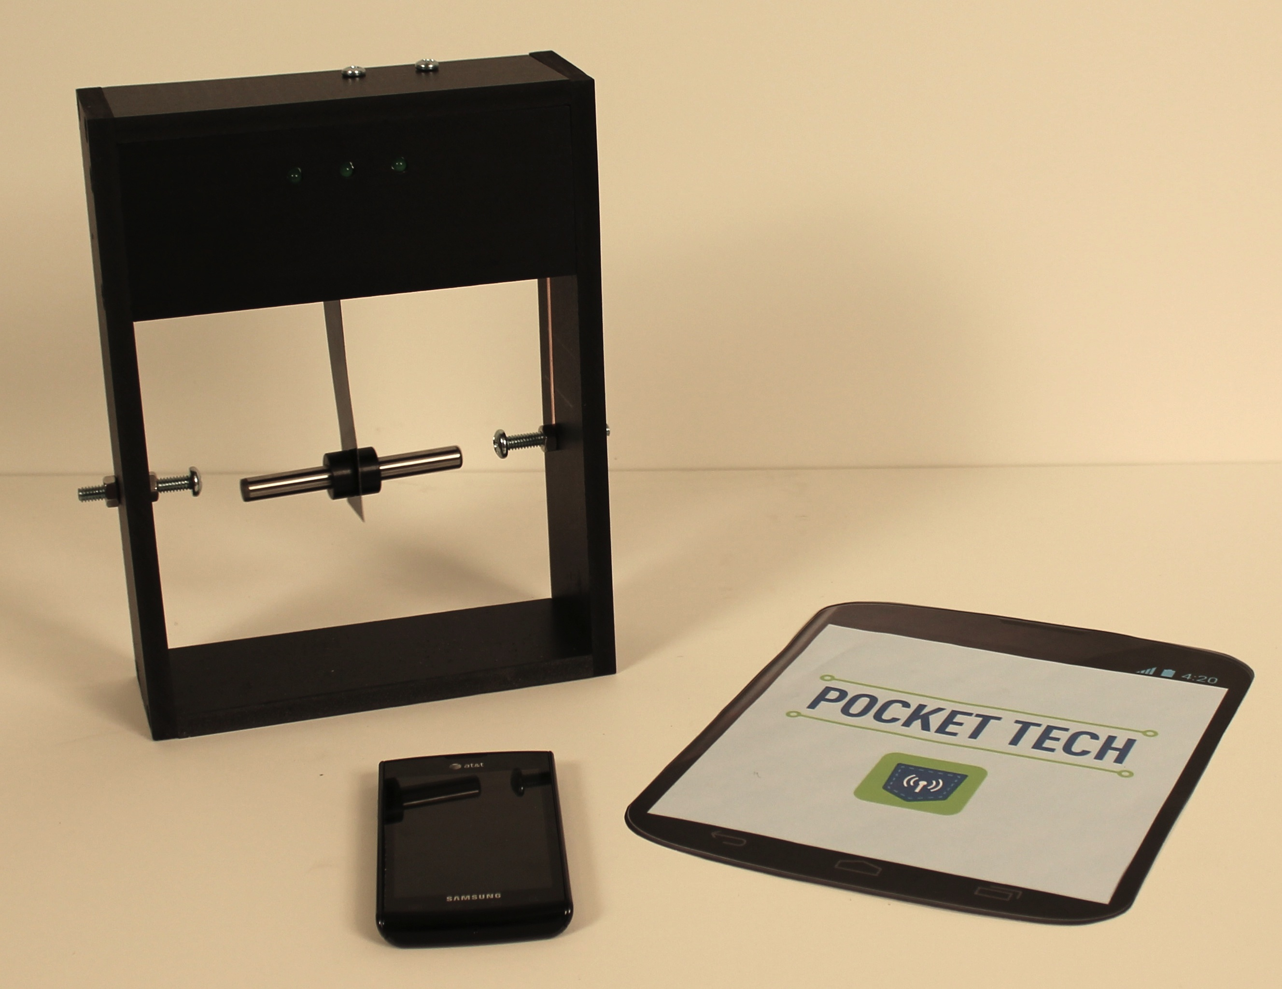
Goal:

Visitors will learn how a handheld device knows up from down to change screen orientation.

Materials:

- Accelerometer model, with attached smartphone graphic
- Smartphone

Procedure:

Set-up:

- Set out the accelerometer model. Turn on the battery pack. Make sure the graphic is attached to the front.

Doing the demonstration:

- Using the smartphone, show visitors what happens when the phone is rotated side to side (the calculator or calendar functions are simple applications to show this). The display automatically rotates to stay upright.

- Ask visitors how the phone “knows” which direction is up. Show visitors the model. Remove the graphic and show visitors the reverse side, pointing out that the computer inside the phone contains an accelerometer that can sense orientation. This model demonstrates what is happening inside the accelerometer.

- Have a visitor rotate the model and observe how the LEDs light up. Point out that one of the LEDs lights up when the weight makes contact with the side of the box. Ask visitors why the metal plate bends when the model is rotated. (As a hint, you may want to ask why the model would fall if you were to drop it.) Gravity always pulls the metal plate down. When the plate moves, the contact sends an electrical signal to the phone, which infers that the opposite direction is up and rotates the screen orientation accordingly.

Clean-up:

- Turn off the battery pack and return the model to storage.

Explanation:

A smartphone contains an accelerometer, a component that measures the downward acceleration of gravity. Accelerometers found in smartphones often make use of a capacitor, a device that can store electricity. This capacitor is composed of two plates, one mobile and the other fixed in place. As the orientation of the phone changes, the mobile plate’s position changes relative to the fixed plate due to the pull of gravity. A sensor measures the change in capacitance (ability to store electricity) caused by this movement. In this activity, electrical contact is used as an analogy to measuring capacitance. By sensing which direction is down, the phone is able to reorient its display appropriately. Aside from smartphones, accelerometers are used to detect orientation and changes of motion in other electronic devices like tablets, laptops, and video game controllers. In cars, accelerometers are used to deploy airbags to protect passengers during collisions.

What could go Wrong?

The weight on the metal plate must make contact with one of the metal screws on either side of the box in order to light the LEDs. If the weight does not reach the screw, try tipping the box more or adjust the screws to protrude farther into the box.

General Maintenance:

Replace batteries when necessary.

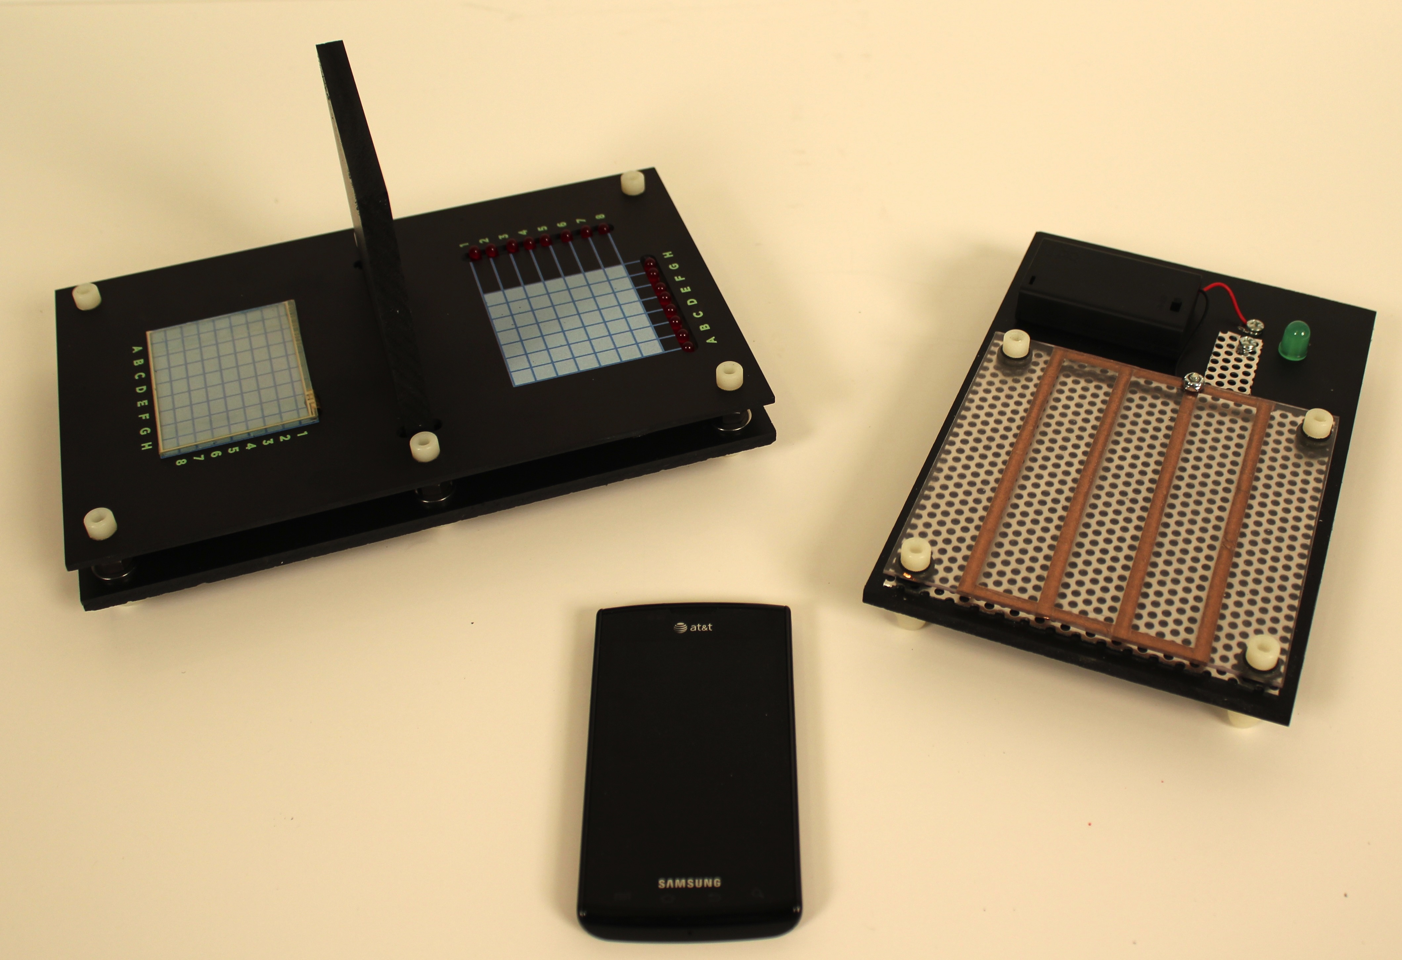
Goal:

Visitors will learn how a touch screen senses and communicates input information.

Materials:

- Find-the-coordinates touch screen device
- Resistive touch screen model (optional)
- Smartphone (optional)

Procedure:

Set-up:

- Turn on battery packs and set out the find-the-coordinates device and the model.

Doing the demonstration:

- Ask visitors where they have used touch screens. Common answers include smartphones, grocery store check-outs, museum exhibits, ATMs, portable gaming devices, etc. How does the computer know where the user is touching?

- Explain that the screen is marked with a tiny invisible grid. The user touches the screen, and the computer has to figure out the location of the touch and translate it into grid coordinates that can then be processed.

- Bring out the find-the-coordinates device and assign one visitor to be the “user” and one to be the “computer.” Explain that the device uses a real Nintendo DS touch screen. Have the “user” press lightly on the screen at a grid point. Have the “computer” read the grid coordinates described by the LEDs that light up on the sides. (If visitors mention the similarity to the game “Battleship,” feel free to expand on that analogy.)

Optional steps for deeper exploration:

- Ask the “user” if they noticed that they had to press down on the touch screen to get it to work, unlike the screen on many smartphones. Allow visitors to compare the pressure needed for the Nintendo DS screen and the smartphone screen. This is because there are two different types of touch screens: resistive and capacitive.

- Bring out the model to show that resistive touch screens have two layers, with air in between them. By physically pressing the sandwich together, the user completes a circuit to send information to the computer. Capacitive touch screens are different because they have a conductive coating applied to a single layer of glass and can directly sense contact from conductive objects, like your finger. Visitors can touch the smartphone to observe the difference in required pressure.

- Discuss with visitors what they think might be the pros and cons of each type of touch screen and what kinds of devices each type is used for.

Clean-up:

- Turn off the battery packs and return all materials to storage.

Explanation:

In many handheld electronic devices, the touch screen is the mechanism for collecting user input for the device’s processor (the logical, “thinking” part of a computer). The processor analyses that information and executes programs accordingly. There are several different types of touch screen technology; the two most common types are resistive and capacitive.

Resistive touchscreens are composed of two sheets separated by a small gap of air. Electrodes on the sheets allow electricity to be passed through them. When you touch the screen, the two sheets are pressed together. The location of this contact can be expressed as a set of coordinates – distance along the X- and the Y-axes. To read the distance along the first axis, a voltage gradient is passed through one sheet and sensed through the other. A sensor reads the output voltage, which reflects the location of the contact. For the other axis, the path is reversed. Voltage is passed through the second sheet and sensed through the first. By rapidly switching back and forth between these two states, the device is able to keep track of where the user is touching the screen.

Resistive touchscreens are commonly used in ATMs, the Nintendo DS, GPS systems, and devices that use a stylus. Advantages of resistive touchscreens include lower cost, compatibility with nonconductive input tools, and greater potential accuracy based on the precision of the grid. Disadvantages include slower response time, lower quality of the display screen, and limited multi-touch gesture capabilities. However, new resistive screens are currently being developed that are capable of more advanced gesture recognition.

Capacitive touchscreens are made of a layer of glass with a transparent conductive coating inside that stores electrical charge. When you touch the screen, your finger draws some of the charge, changing the electric field of the screen. The processor then maps the location of the change using a similar grid coordinate system. Capacitive touchscreens are commonly used in most smartphones, tablets, and touch sensitive monitors.

Advantages of capacitive touchscreens are that they can be manipulated with a lighter, more comfortable touch, are more responsive, transmit more light for better display quality, and can be constructed from thinner, lighter screens. Disadvantages include higher cost, the inability to use nonconductive input tools (this is why popular “smartphone” gloves are made with capacitive thread in the fingers), and less accuracy due to the relatively large surface contact area of a finger.

In most current devices, the touchscreen, whether resistive or capacitive, is a transparent layer separate from the visual display screen underneath. Apple is currently working on a screen that integrates touch recognition with the LCD display, which could make touchscreens even thinner.

What could go Wrong?

When using the find-the coordinates device, remind visitors to press the touch screen gently to avoid breaking the screen. However, because many visitors are also used to using capacitive touch screens with a light touch, you may need to tell them to press down slightly harder on the Nintendo DS screen in order to make the electrical contact.

general Maintenance:

Keep the Nintendo DS screen surface clean by wiping with a dry or slightly damp cloth. Do not spray liquid on the device.

Replace batteries when necessary.

When the device is first turned on, all LEDs illuminate to indicate calibration mode. If the screen is touched during this process, it will have to be recalibrated.

To recalibrate:
  - Press and hold the center of the screen.
- Turn power on.
- Wait for two corner LEDs to blink.
- Press and hold corresponding corner on screen until LEDs stop blinking.
- Repeat steps 3 and 4 for opposite corner.

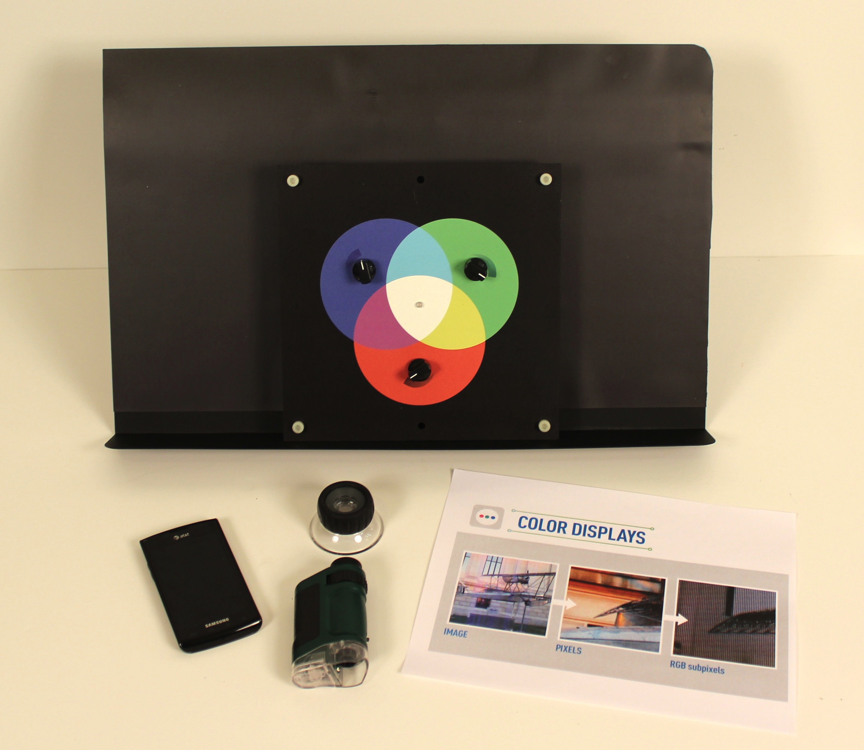
Goal:

Visitors will discover how tuning the color of subpixels within a visual display can create an apparently continuous image.

Materials:

- Display stand (optional)
- Smartphone
- Graphic of pixel magnification
- 17.5X power magnifier
- 20-40x pocket microscope
- Subpixel color mixing device

Procedure:

Set-up:

- Turn on phone and display the photo of the airplane.
- Make sure microscope is set to highest magnification.
- Place the color mixing device on the display stand and turn it on.

Doing the demonstration:

- Ask visitors what they know about how the color display on a smartphone works.

- Show visitors the picture on the phone. Explain that even though the picture looks continuous to our eyes, it is actually made up of tiny individual dots called pixels. Show visitors the printed image of pixel magnification.

- Place the 17.5X magnifier over the screen to show visitors the individual pixels.

- Explain that each pixel is made up of three subpixels–red, green, and blue. The computer inside the phone precisely controls the color of these subpixels so that together, they make the pixel appear to be the color that our eyes perceive. If we look even closer, we can actually see these subpixels. Show visitors the printed image of subpixel magnification.

- Help visitors hold the 20-40x microscope to the display (preferably over an area of white) and look into the eyepiece. Ask visitors if they can see the red, blue, and green subpixels.

- Show visitors the color mixing device and explain that the central LED represents one pixel. Set the knobs to a relatively low level so that the three subpixels are visible.

- Allow visitors to play with the device to see if they can produce different colors.

Clean-up:

- Turn off the electronics and return all materials to storage.

Explanation:

Electronic display screens on smartphones, computers, and other electronic devices are made up of individual elements called pixels. The number of pixels in the display determines the resolution of the screen; e.g. “1024 x 768” means that there are 1024 pixels that fit along the width and 768 pixels that fit along the height. Although our eyes generally perceive a continuous image being displayed, we can see these individual pixels if we look closely or magnify the screen. In Apple’s “Retina Display” technology, the density of pixels is so high that the human eye cannot see the pixelation at an average viewing distance.

Within each pixel, there are three subpixels–red, blue, and green. The computer controls how much of each color is emitted within the pixels. To our eyes, these different levels of red, blue, and green mix so that each pixel appears to be a different color. The different color pixels then make up the image that we see. The arrangement of the subpixels affects both the contrast and the viewing angle of the screen.

Smartphone display screens are made using liquid crystal display (LCD) technology. LCDs do not emit light, so they have to be backlit with color filters on top. These nanoscale liquid crystals are like twisting ladders inside the subpixels. Normally, the crystals twist at right angles and let all the light through to the color filters. When energy is added, they twist away and prevent light from reaching the color filters. The computer controls how much energy is added to each subpixel to determine what color it appears.

What could go Wrong?

Some visitors may not know what they are “supposed” to see through the magnifier and microscope. Use the graphic to help them know what to expect.

At the highest light intensities of the color mixing device, some visitors may find the light to be too bright. Encourage them to try mixing colors at lower intensities.

GENERAL MAINTENANCE:

Replace batteries when necessary.

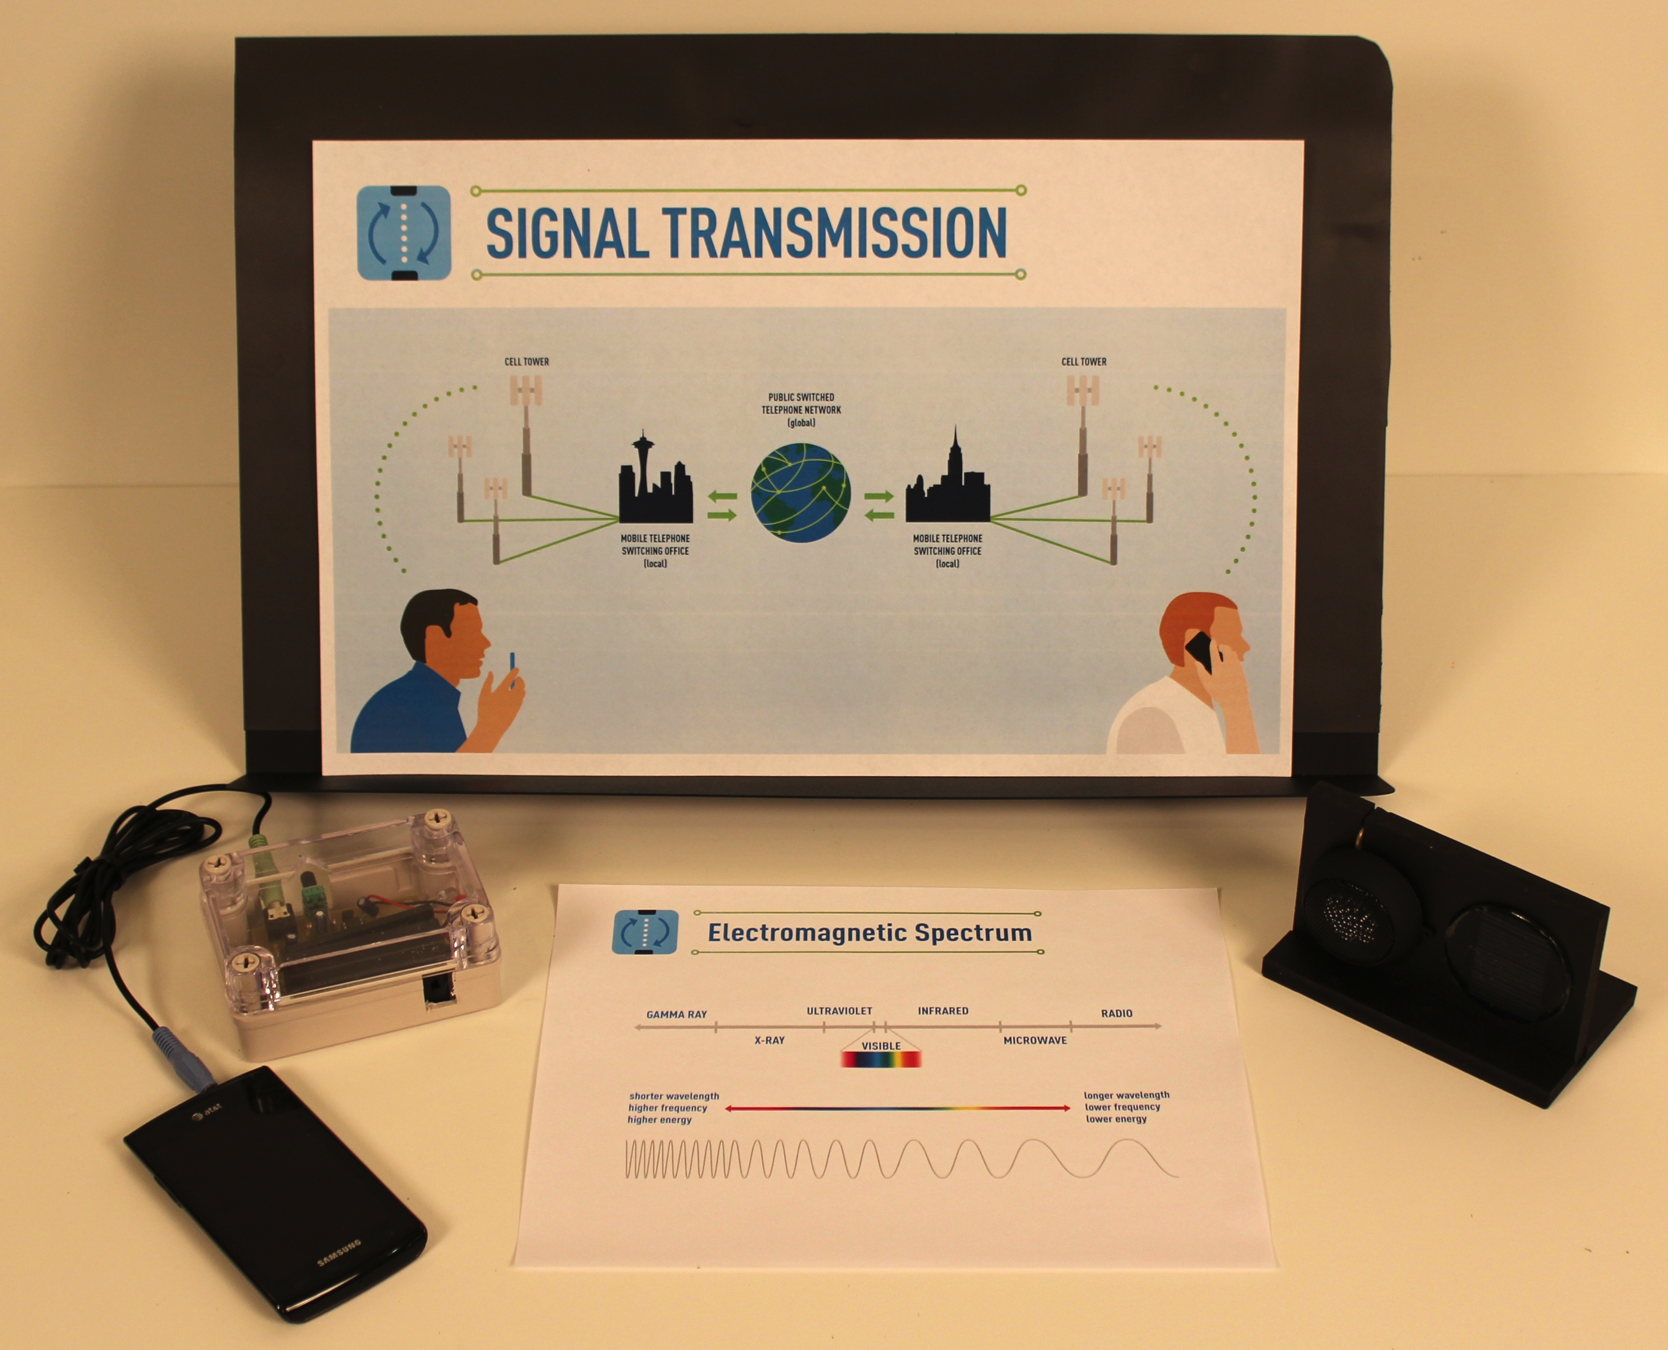
Goal:

Visitors will learn how electronic devices communicate wirelessly.

Materials:

- Display stand (optional)
- Smartphone
- Transmitter box
- Solar cell receiver/speaker assembly
- Connection cable (phone to transmitter box)
- Electromagnetic spectrum graphic
- Mirror (optional)
- Cellular network graphic (optional)

Procedure:

Set-up:

- Display the cellular network graphic on the stand. (optional)
- Connect the smartphone to the transmitter box.
- Turn on all electronic devices.
- Cue up the smartphone to play music.

Doing the demonstration:

- Ask visitors what they know about how cell phones send and receive signals.

- Explain that cell phones use invisible signals to communicate. This demonstration will use a signal that we can see (visible light) to help us understand how cell phones work.

- Start the music on the smartphone (the solar cell receiver should not be aligned with the transmitter at this point). Ask visitors what they see and hear. Then have a visitor line up the solar cell with the beam of light from the transmitter. The music should now be audible through the speaker.

- Explain that a transmitter inside the phone converts sound (music or your voice) into an electromagnetic wave. Using the electromagnetic spectrum graphic, show visitors that cell phones normally use the radio wave part of the spectrum that is invisible to our eyes, while here we are using the visible part of the spectrum so that we can see what is happening.

Optional steps for deeper exploration:

- Allow visitors to play with the positions of the transmitter and receiver to explore different factors affecting cellular signal transmission. For example, change the distance of the receiver or block the light coming from the transmitter. You can also reflect the transmitted light back towards the receiver using a mirror to illustrate how signals can bounce off of objects. Help visitors connect their explorations to actual situations they’ve experienced when using their cell phones.

- Show visitors the cellular network graphic to discuss the steps involved in a real phone call. Point out that the wireless communication takes place between the phone and cell tower, not directly from phone to phone.

Clean-up:

- Turn off the electronics and return all materials to storage.

Explanation:

When you speak into a cell phone, the microphone and transmitter inside transform the sound of your voice into electrical signals. The phone’s antenna then broadcasts these electrical signals as radio waves. An antenna on the cell tower picks up those radio waves, and the cell tower’s receiver converts them back into electrical signals. These electrical signals are carried along physical cables to the Mobile Telephone Switching Office, which connects to the Public Switched Telephone Network, which routes all telephone calls around the world. When you call another cell phone, the call is directed to the recipient’s local switching office and then onward to the closest cell tower. The cell tower converts the signals back into radio waves that are picked up by the antenna on the recipient’s phone and transformed back into sound by an internal receiver and speaker.

In this demonstration, instead of an antenna for radio waves, the transmitter box uses an antenna that converts the signals to visible and infrared light waves, using LEDs as a light source. A simple solar cell is used on the receiver box to pick up those light waves and convert them into electrical signals, which the speaker transforms back into sound. If you look closely at the light source, you may be able to see it pulsing in time with the vibration of the music, demonstrating how the light waves are encoding the digital information.

When using a cell phone, there are a number of factors that affect the quality of transmission and the likelihood of a dropped call, several of which can be simulated in this demonstration. Proximity to the cell tower is one factor, as illustrated by the decrease in volume as the transmitter box and receiver are moved farther apart. In a real cellular network, this problem is avoided by switching the call to a different cell tower as the caller moves around. A second issue is the “dead spot,” where hills, trees, or buildings can interfere with signals reaching the cell tower. You can simulate this by using your hand or another object to block the light. However, another interesting phenomenon can sometimes occur as a result of reflection; just as visible light bounces off a mirror (or the side of a glass building), all parts of the electromagnetic spectrum can be reflected and redirected. A third issue is sufficient power. Just as cell phones are more likely to drop calls when they are not fully charged, this demonstration will work best when all electronic components have adequate power.

What could go Wrong?

For younger audiences, you may wish to skip the discussion of the cellular network and focus primarily on the phenomenon of sending and receiving signals.

General Maintenance:

Replace batteries as necessary.

Project Contributors

 |  | Keeley Briggs  Al Bruno  Jayatri Das  Bob Freer  Brigette Indelicato  Brian Kelly  Brandon Klevence  Steve Snyder  Eric Welch  and others
   |  | Vin Crespi  Tso-Yi Chiang  Ashley Dasilva  Kristin Dreyer  Derek Keefer  Rod Kreuter  Tom Mallouk  Ryan Pavlick  Arnab Sengupta  Darrell Velegol  Wei Wang  Yu Yuwen  Yanhui Zhao  and others

